Planning Lessons

Aspects to consider before planning:

A good lesson plan is:
Coherent – includes a logical connection among the activities, thus ensuring continuity;
Varied – includes different activities that suit all learning styles but meet the same objectives;
Challenging – activities adjusted to learners’ needs;
Flexible – allows for changes;
Proportionally structured – it consists of a mixture of elements: methods, activities, forms of interaction, contents, etc.

Specific competences  CS 1 (linguistic). Aplicarea normelor lingvistice în formularea de mesaje simple şi corecte, valorificând limba ca sistem  CS 2 (socio-linguistic). Utilizarea structurilor lingvistice, demonstrând funcționalitatea limbii în cadrul unui contact social  CS 3 (pragmatic). Utilizarea structurilor lingvistice în cadrul unor contexte familiare și previzibile, demonstrând coerență și precizie în comunicare  CS 4 (pluri/intercultural). Aproprierea elementelor specifice culturii țărilor limbii străine studiate, manifestând deschidere și motivație pentru dialog intercultural | Units of competence (long-term acquisitions)  E.g. 1.1, 1.2, 1.5,  1.8, 1.9, 1.10, 1.11  2.2, 2.3  2.5, 2.7  3.2, 3.3, 3.4, 3.7 (Household Chores, The Definite Article “The”, Word Combinations) | Learning objectives (during the lesson)

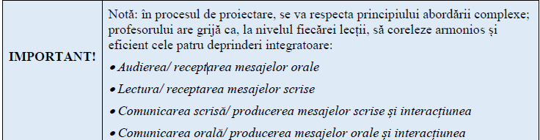

Student’s interaction:
Individual – students work on their own;
Pairwork -
Pairs of students in discussion with other pairs -
Small group – (three to six people);
Large groups
Whole class mingle (all stand up, walk around, meet and talk)
Whole class plenary

Objectives should be S.M.A.R.T.:
- Specific – be precise about what you are going to do
- Measureable –you will know when you have reached your goal
- Achievable – do not attempt too much; a less ambitious but completed objective is better than an over-ambitious one that you cannot possible achieve.
- Realistic – do you have the necessary resources to achieve the objective?
- Time constrained – determine when each stage needs to be completed.

Use strong positive statements which use strong verbs. Avoid weaker verbs.
Strong verbs: present, review, define, collect, construct, classify, develop, devise, measure, produce, revise, select, synthesize, compare.
Weak verbs: appreciate, consider, enquire, learn, know, understand, be aware of, appreciate, listen, perceive.

Make the following objectives smart:
- Students will create a dialogue;
- Students will create their own product according to the model;
- Students will complete a postcard;
- Students will list the advantages of reading;
- Students will discuss the sightseeing places in USA.

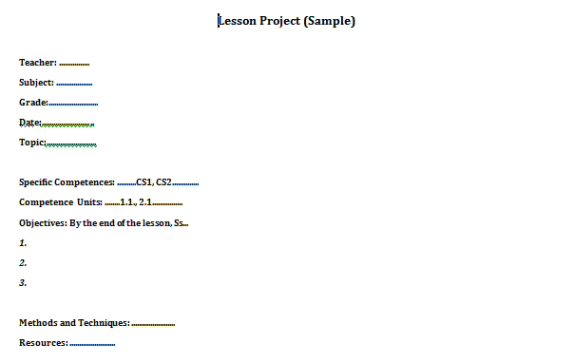

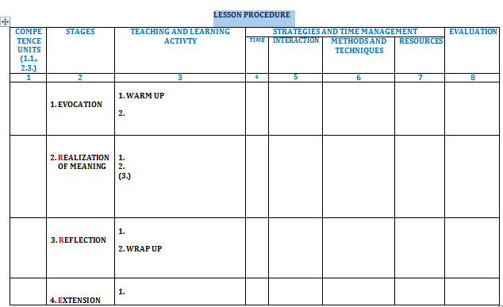

ERRE Framework:
The ERRE (Evocation, Realisation of Meaning, Reflection, Extension) framework system is a way of thinking and teaching that enhances students' critical analysis, giving meaning and critical reflection. It consists of three phases and it is a good model of the best way people learn. The model describes the process of thinking in which students are included before the process of learning, during the process and after the learning process.
- Evocation (E)
- Sts. are encouraged to use their knowledge and experience on a particular subject and to anticipate and determine the purpose of teaching and learning.
- Sts connect the previously acquired knowledge with knowledge that is being acquired. This enables the transfer of knowledge.
- Activating students’ schemata (ˈskiːmətə) - the process of activating the sts’ prior knowledge, a technique that can help to reduce the memory load. It allows them to tune in to the topic and helps them to develop their expectations of the input
- Realization of meaning (Rz)
- Gets the students through a new text analysis, thematic presentations or other form of presentation of new contents.
- Learners are expected to experience new content and integrate it into their own knowledge.
- The information is acquired through reading a text, listening to a piece of discourse, watching a movie, doing/carrying out an experiment.
- Sts is fully involved in discovering the meaning of the content.
- Sts are encouraged to analyze, compare, synthesize, generalize and monitor their own understanding (clarification focus).

- Reflection (R)
- Sts think about what they have learned in the context of their existing knowledge, rearrange the existing knowledge, build a link between the existing and new knowledge and create a new quality.
- Sts acquire new knowledge and develop new skills. This is possible only if students get actively involved in restructuring / rearranging existing knowledge so as to fit in new knowledge.
- Sts express the new knowledge in their own words, bring the new knowledge in their personal contexts and get feedback from peers or teachers (controlled practice/restricted output).

- Extension (E)
- The transfer of knowledge has occurred.
- Teachers create contexts for students to try out real language, e.g. simulations, role-plays, advertisement design (sts write and record a radio commercial), debates and discussions, etc.
- Sts solve authentic tasks (in a given set of circumstances, in a specific environment and within a particular field of action. (Authentic output).

Sequence

Engage – the point in the teaching sequence where teachers try to arouse the student’s interest, thus involving their emotions. Activities and materials that frequently engage students: games, depending on the age and type, music, discussions (when handled challengingly), stimulating pictures, etc. Students may Engage with the topic before reading about it by being asked what they think about this topic, predicting the topic by looking at a picture of a person and saying what occupation the person has.

Study – Activities in which students focus on language and how it is constructed. They range from the study and practice of a single sound to an investigation of how a writer achieves a particular effect in a long text, etc. Students can study in a variety of different styles: the teacher can explain grammar, they can use the language evidence to discover grammar form themselves, they can work in groups studying a reading text or vocabulary. It is the stage at which the construction of language is the main focus, e.g. study and practice of paragraph organization.

Activate - includes exercises and activities designed to use language freely and “communicatively”. The objective is to focus on lge construction/practice specific bits of lge, but to use the language which may be appropriate for a given situation or topic. Thus, Activate exercises offer students to try out real language, e.g. role-plays, advertisement design (sts write and record a radio commercial), debates and discussions, etc.

Variations:

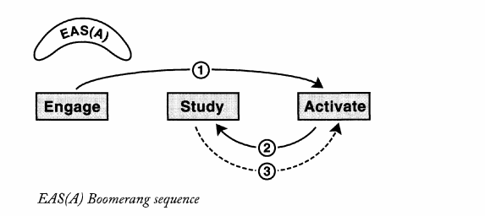

ESAA correlates with the task-based learning TBLT

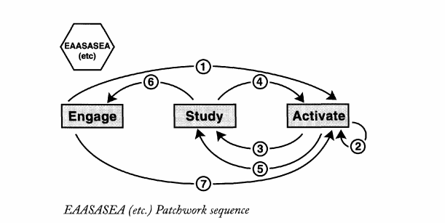

Compare the ESA sequence to the ERR framework:

Other Models:

Presentation - Practice – Production (immediate creativity, i.e. sts create sentences of their own sentences)
(Knowledge Accuracy (precision) Fluency)

ARC – Authentic use Restricted use Clarification and focus
(communicative activity) (drill, jazz chant, elicited dialogue, guided writing) (explain grammar, give examples, analyze errors, elicit or repeat)

Correlate the following stages of the lesson with the ERRE framework:
Exposure
Clarification and Focus:
Activities that promote noticing and discovery
Restricted output

Authentic output
Extention

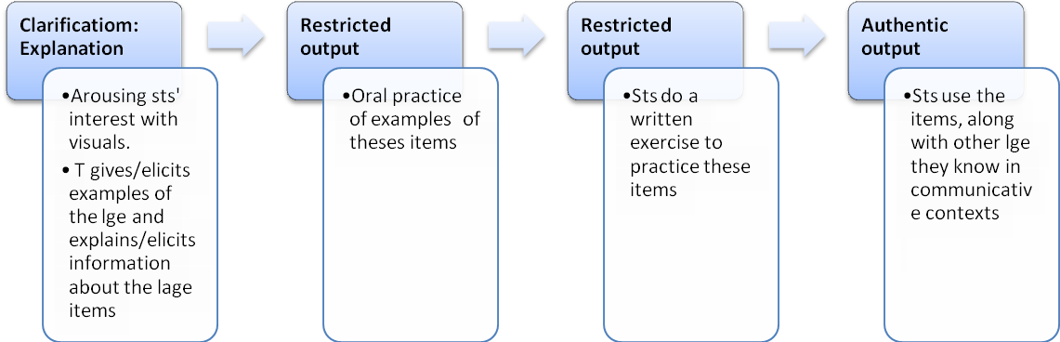

Complete the figure:
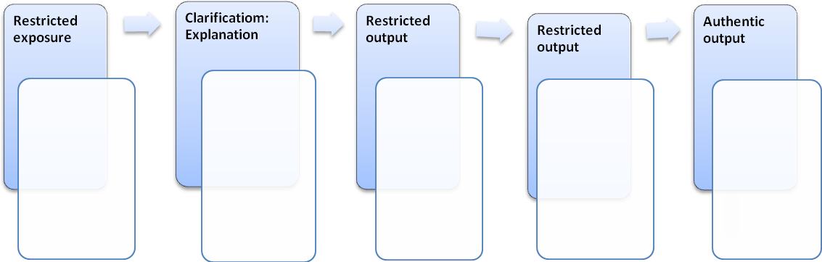

Evocation | Realization of meaning | Reflection aplicre/integrare | Extention
- Brainstrorming  - Clustering  - Free writing  - Assciations  - Star bursting  Situations  - Functions  - Mystery headlines  - Problem-solving  Opinions, ideas and facts  - KWL charts  - Speed writing  - Group writing  - Quotations  - Backgrounding  - Quizzes  - Predictions using visuals, key words from the text | - Demonstration  - Guided discovery  - Explanation  DARTs – directed activities related to texts:  Reconstruction activities:  - Close  - Sequencing/ordering  - Ordering  - Diagram completion  - Prediction activiies  Analysis activities:  - Text marking  - Text construction  - Diagram construction  - Table construction  - Questioning  - Summarizing  - KWL table  - Intensive reading  - Guided reading  - Listening for gist  - Listening for detail/Selective listening  - Inferring  - Note-taking  - Dictation  Interactive dictation  Dictogloss  Picture dictation:  Gapped/Whistle-gap dictation  False facts dictation  - Listen and do  - Simon says  - Stand up if...  - Mime  - Drilling  - Chants  - Milling activities | - Drills  - Gap-fill task  - Ordering tasks  - Expansion tasks  - Transformation tasks  - Dialogues  Items on board  Chunks on cards  Memorizing scripts  Disappearing dialogue  Dialogue building  - Communicative tasks  Information gap activity  Jigsaw activity  Blocking games  Guessing game  - Task repetition  The Onion  - Storytelling based activities  Guess the lie  Insert the word  Chain story  - Role-play and simulations  Alibis  Shopping around  - Discussion and debates  Discussion cards  Warm-up discussions  Pyramid debate  Panel discussions  - Conversation and chat  Sentence star  True/false sentences  One of us /some of us  - Concept mapping  - Venn’s diagram  - Fishbone diagram | - Negotiations  - personalization  - Discussion and debates  - Writing a postcard  - Wrting a letter

